Project
Adding a System Call In Our Kernal

Group Members:

M.Bilal Ahmed(61438)
Saleh Hayat
Najam Khan

Note: This is not possible to work it on individually because we need a common PC to add system call
we work togetter in my pc(bilal) everytime and done this all step together.
And this is our 75% project we just have to restart our pc and check our system call is working or not.

1-First we enter in our root directory as a super user
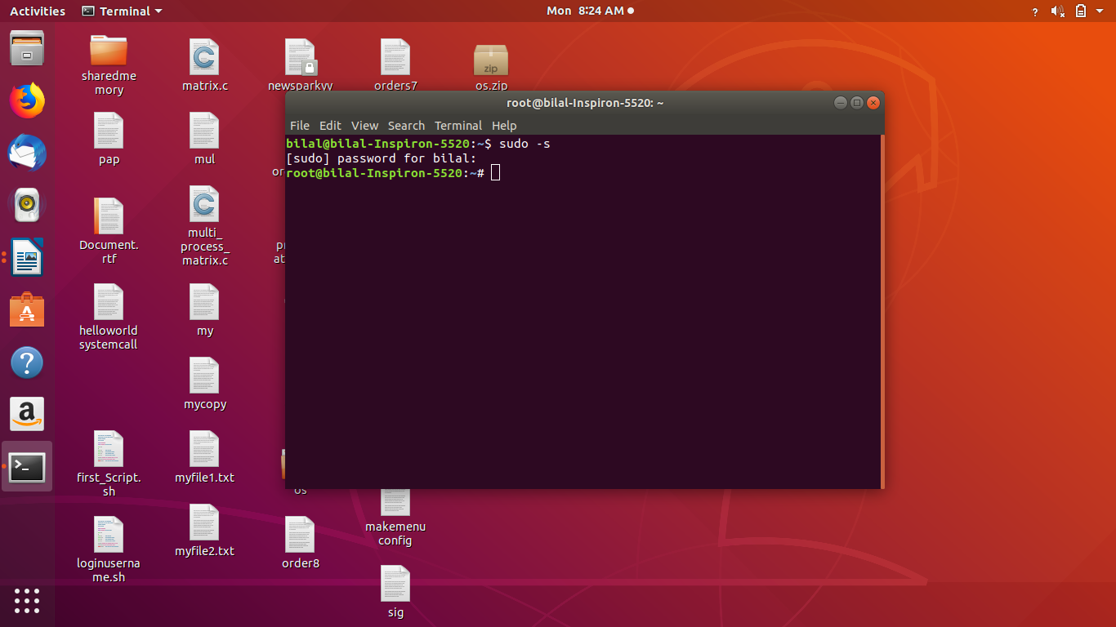

2-Then we download linux kernal files by the following Command:
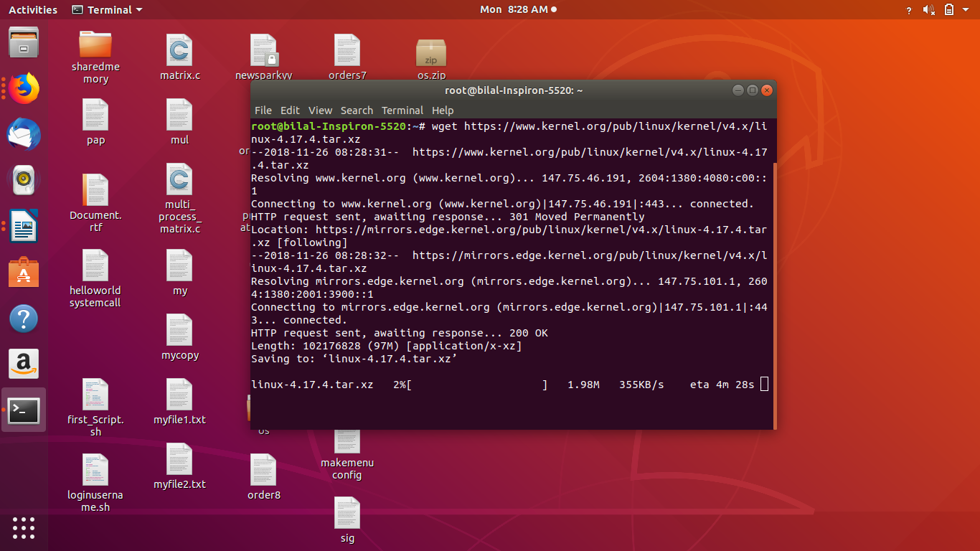
3-Then We Extract the kernel source code by the following command in directory usr/src

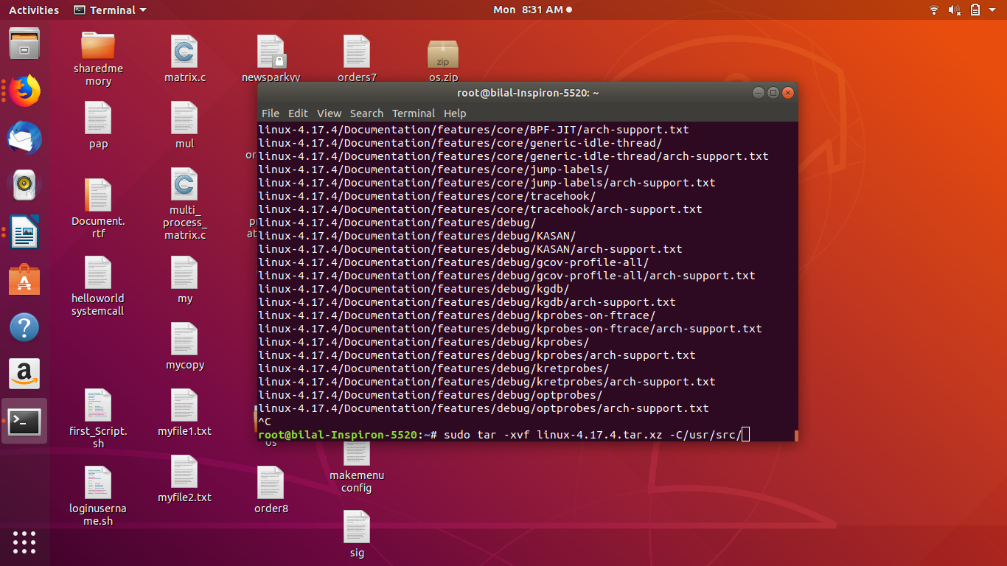

4-then we enter into linux-4.17.4 by the following command
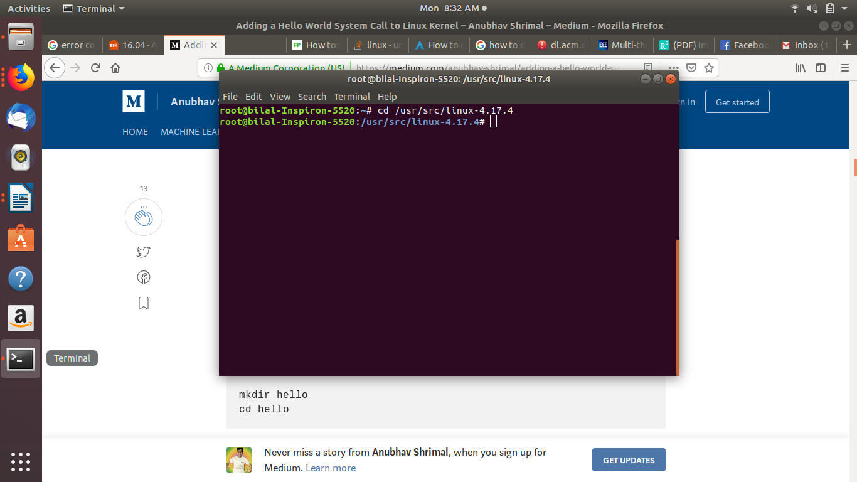

5-Then we make directory of “helloworld” and then enter into it by the following command:
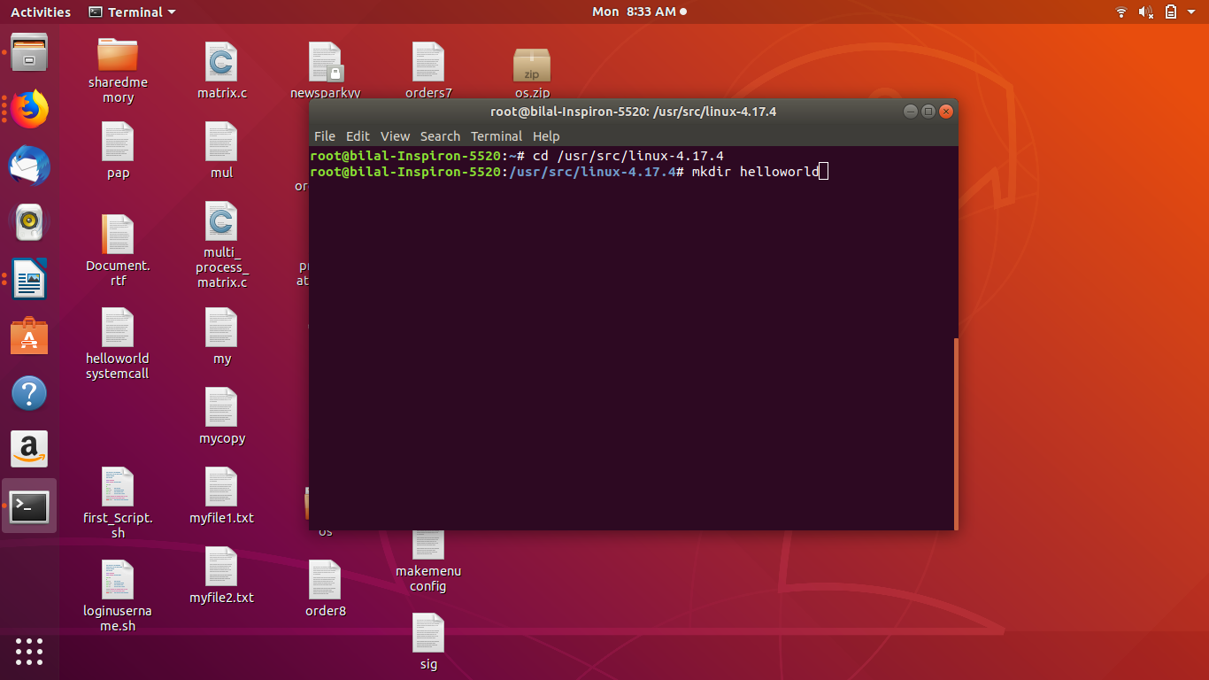

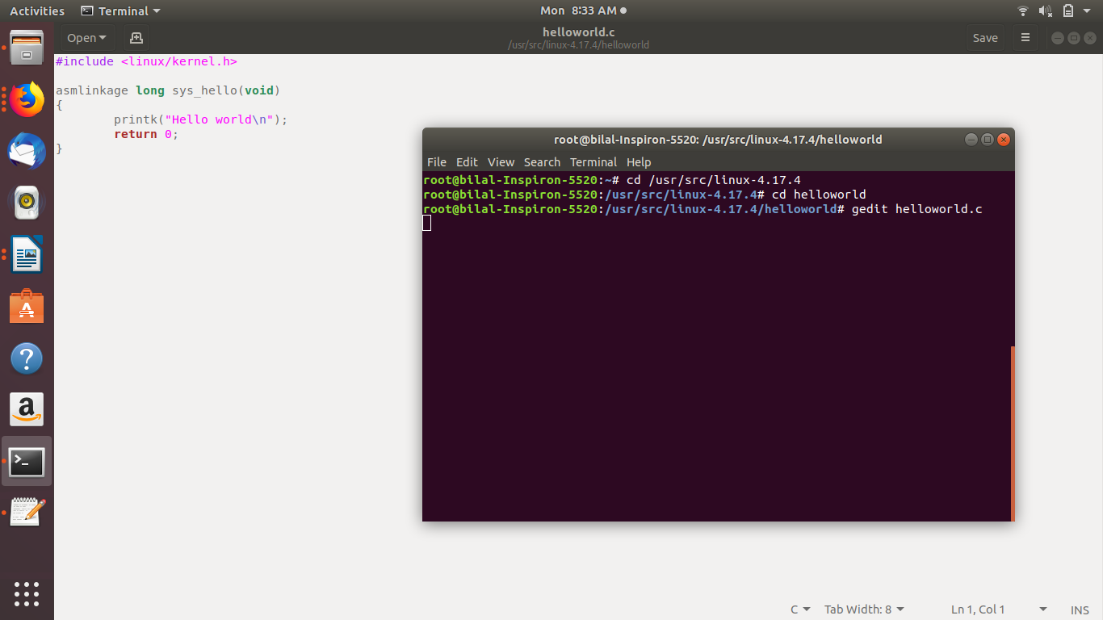
6-Then we make “helloworld.c” the helloworld systemcall file
7- Then we make “Make file” because this is to ensure that the hello.c file is compiled and included in the kernel source code.
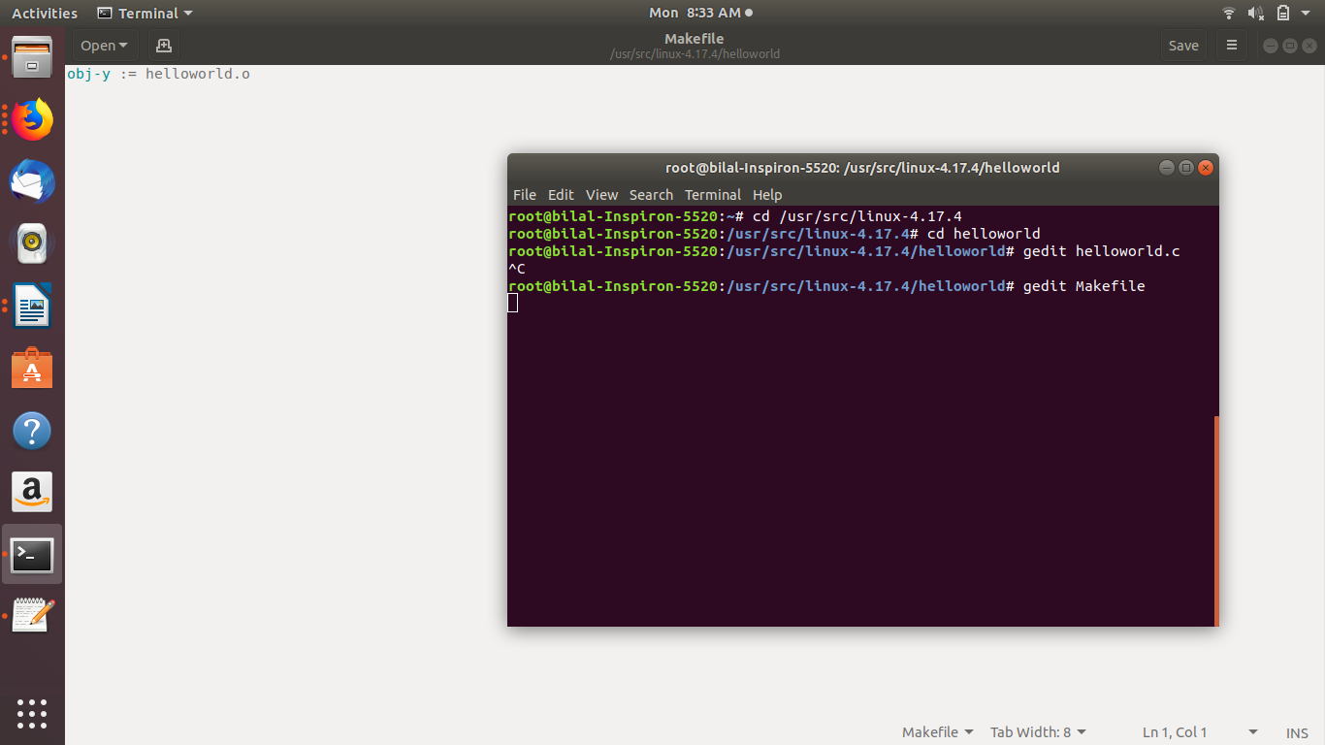
8-4. Adding helloworld/ to the kernel’s Makefile:

then we go back to the parent dirrectory i.e. cd ../ and open Linux owned“Makefile”
gedit Makefile
search for core-y in the document, you’ll find this line as the second instance of your search:
core-y += kernel/ mm/ fs/ ipc/ security/ crypto/ block/
Add ‘hello/’ to the end of this line:
core-y += kernel/ mm/ fs/ ipc/ security/ crypto/ block/ hello/
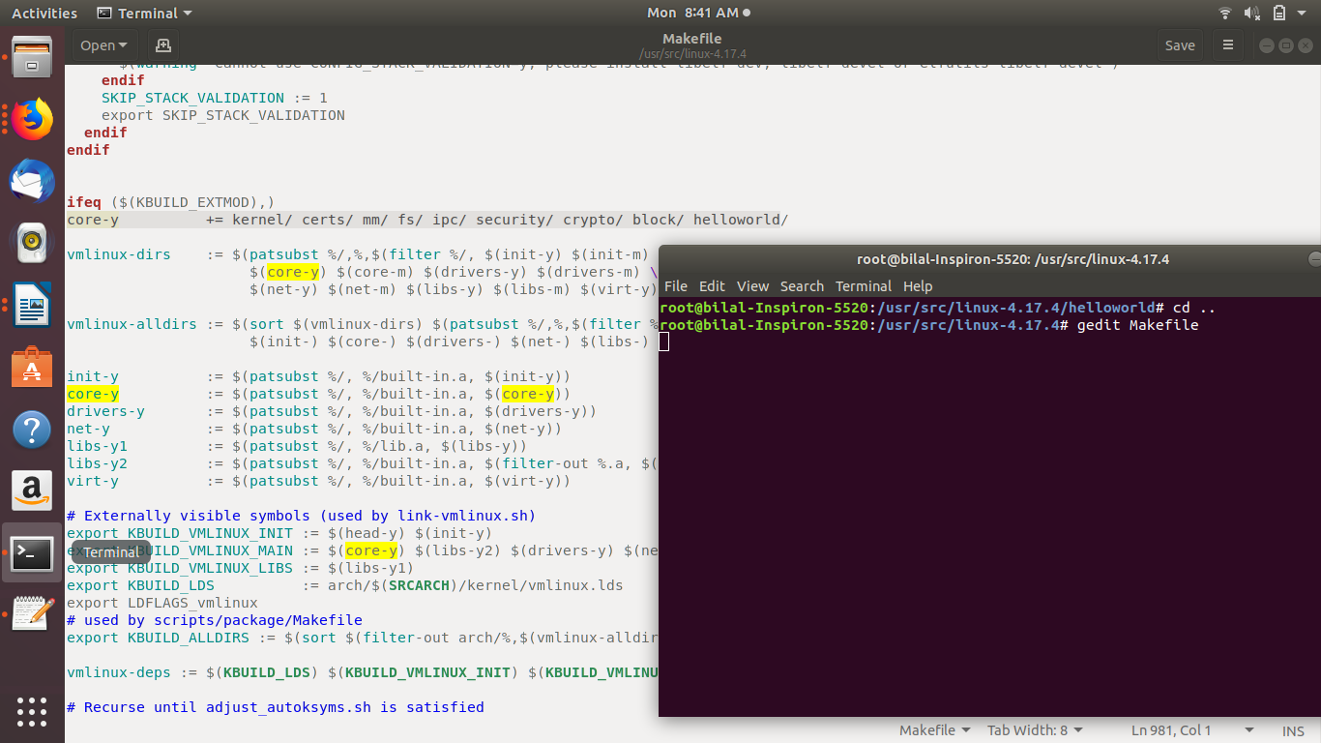
9-Then we add System call to system call table for which we have go in directory:
cd arch/x86/entry/syscalls/
gedit syscall_64.tbl

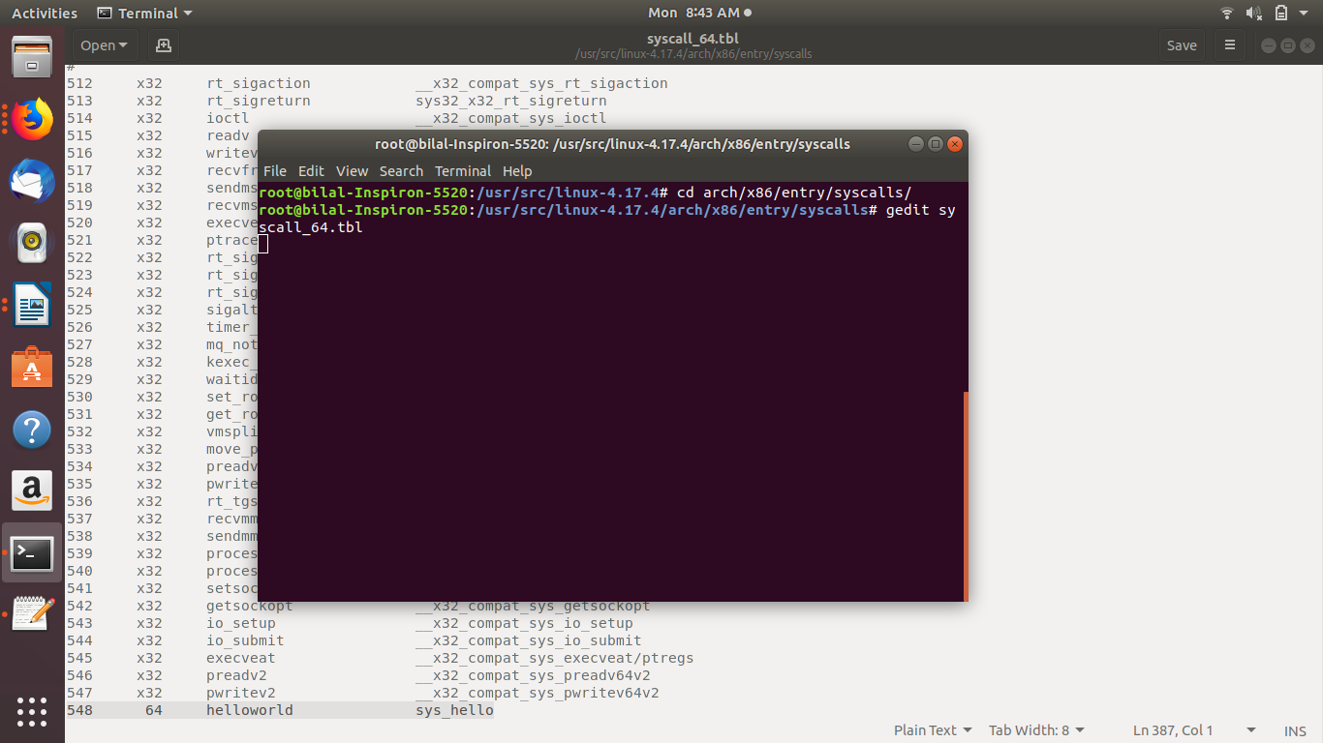

as you see helloworld named directory on 548 number and sys_hello is the name of our system call.

10-Then we add new system call to the system call header file:

cd include/linux/
gedit syscalls.h

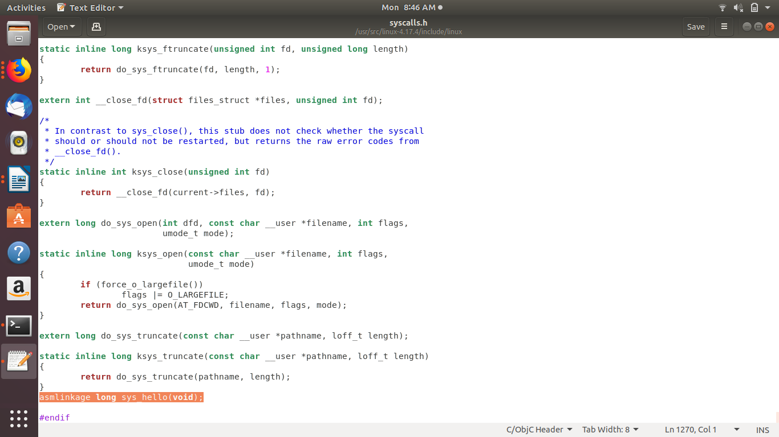

Then Highlighted one is our system call.

11-Then We use “make menuconfig” to configure Linux source, a necessary early step needed to compile the sourcecode.

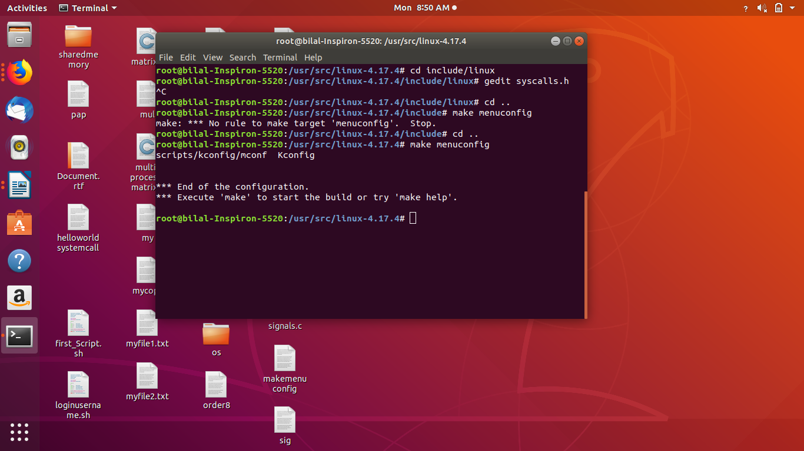
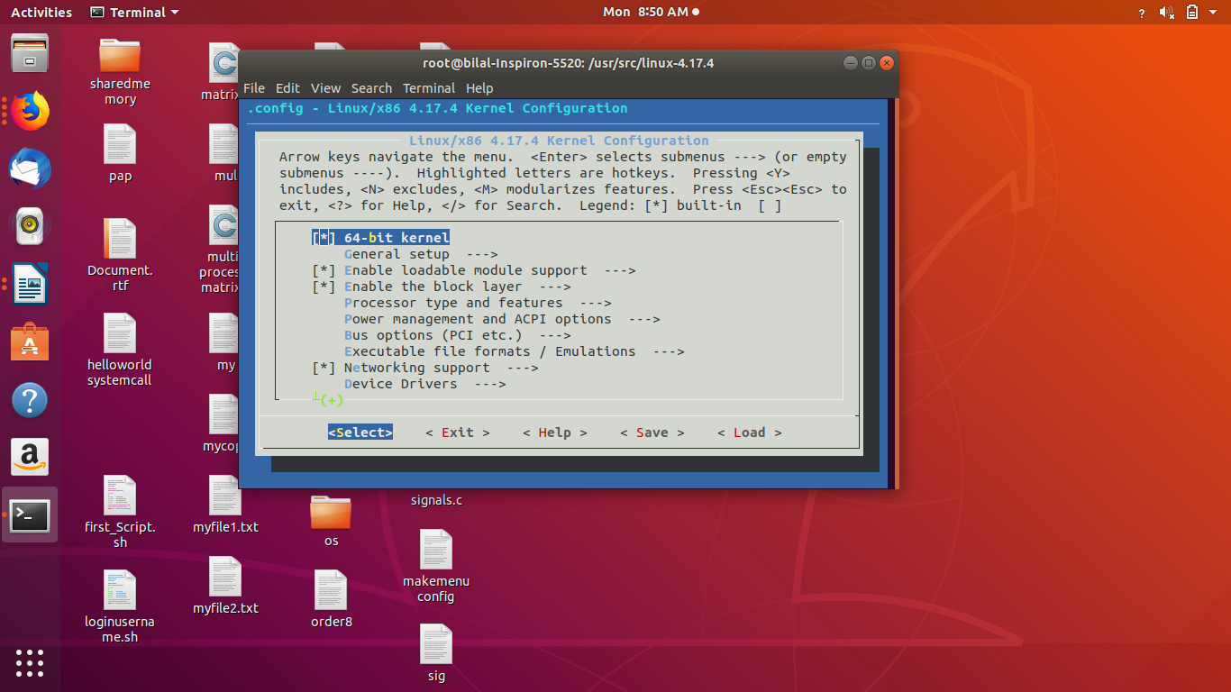

12-Then we use “Make” command to compile the kernal of linux

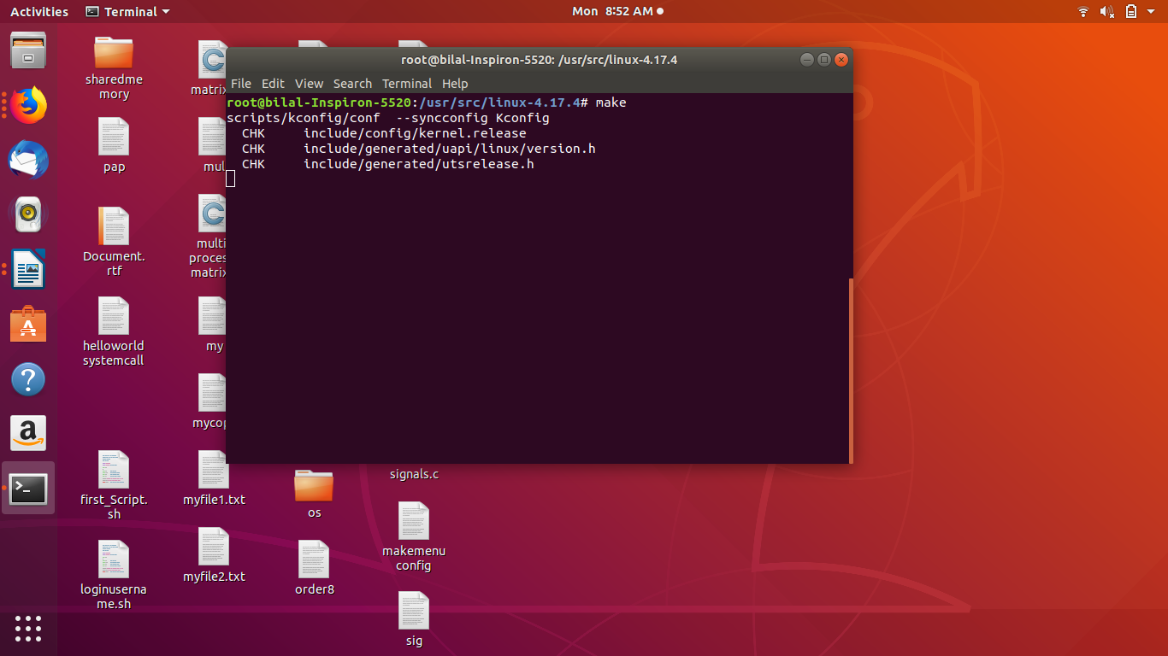
After 3 hours of compilation(We have face many issues while compiling we will include in our final report)
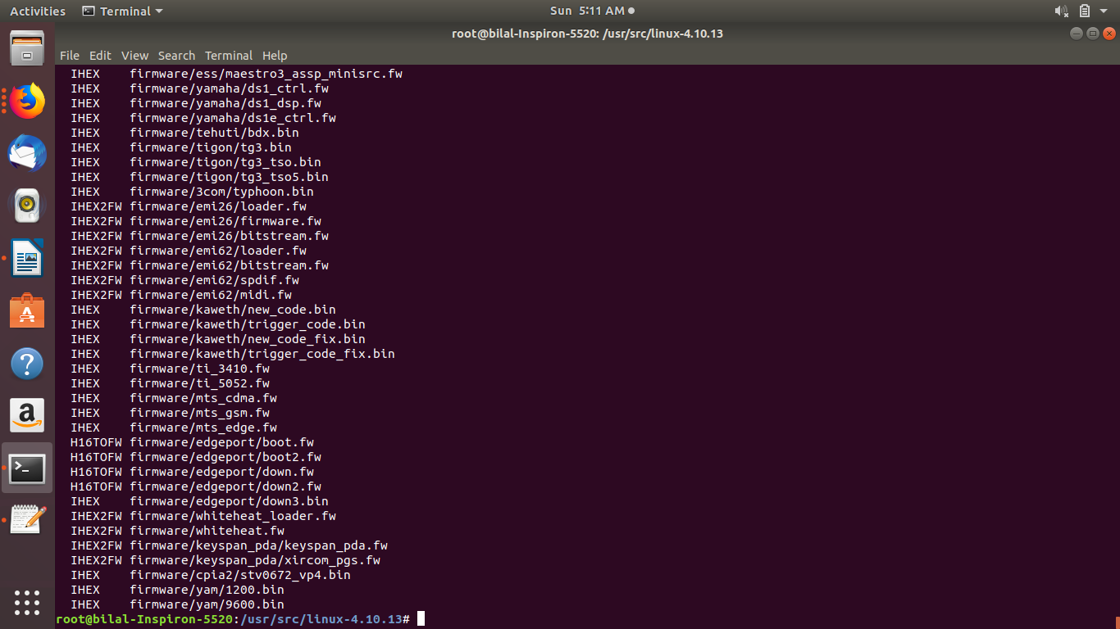

12-Then we run “make modules_install install” to install the compiled linux version to install or overwrite our existing kernal

